Assignment 8,10

package com.example.assignment8and10;

import javafx.event.ActionEvent;

import javafx.fxml.FXMLLoader;

import javafx.scene.Node;

import javafx.scene.Parent;

import javafx.scene.Scene;

import javafx.scene.control.Label;

import javafx.stage.Stage;

import java.io.IOException;

import java.sql.*;

import java.util.Objects;

public class DBUtils {

    public static void enter_to_database(Label notif, String employee_Id, String name, String email, String department, String age, ActionEvent event) throws SQLException {

        Connection connection = null;

        PreparedStatement psInsert = null;

        PreparedStatement psCheckUserExist = null;

        ResultSet resultSet = null;

        try {

            connection = DriverManager.getConnection("jdbc:mysql://localhost:3306/DB", "root", "laksh");

            psCheckUserExist = connection.prepareStatement("SELECT * FROM employee WHERE employee_Id  = ?");

            psCheckUserExist.setString(1, employee_Id);

            resultSet = psCheckUserExist.executeQuery();

            if (resultSet.isBeforeFirst()) {

                notif.setText("It already Exists");

            } else {

                psInsert = connection.prepareStatement("INSERT INTO employee(employee_Id,name,email,department,age) VALUES(?,?,?,?,?)");

                psInsert.setString(1, employee_Id);

                psInsert.setString(2, name);

                psInsert.setString(3, email);

                psInsert.setString(4, department);

                psInsert.setString(5, age);

                psInsert.executeUpdate();

                DBUtils.details_changeScene(event, "viewdetails.fxml");

            }

        } catch (Exception e) {

            e.printStackTrace();

        }

    }

    public static void details_changeScene(ActionEvent event, String fxmlFile) throws IOException {

        Parent root = null;

        FXMLLoader loader = new FXMLLoader(DBUtils.class.getResource(fxmlFile));

        root = loader.load();

        Stage stage = (Stage) ((Node) event.getSource()).getScene().getWindow();

        stage.setTitle("Details");

        stage.setScene(new Scene(root, 600, 400));

        stage.show();

    }

    public static void update(ActionEvent event ,String id, String name, String age, String dept, String email) {

        String sql = "UPDATE employee SET  name = ?, email = ?, department = ?,age = ? WHERE employee_Id = ?";

        try (Connection con = DriverManager.getConnection("jdbc:mysql://localhost:3306/DB", "root", "laksh");

             PreparedStatement stmt = con.prepareStatement(sql)) {

            stmt.setString(1, name);

            stmt.setString(2, email);

            stmt.setString(3, dept);

            stmt.setString(4, age);

            stmt.setString(5, id);

            stmt.executeUpdate();

            DBUtils.details_changeScene(event,"viewdetails.fxml");

        }

        catch (IOException e) {

            e.printStackTrace();

        } catch (SQLException e) {

            throw new RuntimeException(e);

        }

    }

}

package com.example.assignment8and10;

import javafx.collections.FXCollections;

import javafx.collections.ObservableList;

import javafx.event.ActionEvent;

import javafx.event.EventHandler;

import javafx.fxml.FXML;

import javafx.fxml.Initializable;

import javafx.scene.control.*;

import javafx.scene.control.cell.PropertyValueFactory;

import javafx.scene.layout.VBox;

import javafx.scene.input.MouseEvent;

import java.net.URL;

import java.sql.*;

import java.util.ResourceBundle;

public class ViewDetailsController implements Initializable {

    @FXML

    private Label welcomeText;

    @FXML

    private TableView<ViewTable> table;

    @FXML

    private TableColumn<ViewTable, String> emp_id;

    @FXML

    private TableColumn<ViewTable, String> name;

    @FXML

    private TableColumn<ViewTable, String> email;

    @FXML

    private TableColumn<ViewTable, String> dept;

    @FXML

    private TableColumn<ViewTable, String> age;

    @FXML

    private javafx.scene.text.Text label_name;

    @FXML

    private javafx.scene.text.Text label_dept;

    @FXML

    private javafx.scene.text.Text label_Id;

    @FXML

    private javafx.scene.text.Text label_email;

    @FXML

    private javafx.scene.text.Text label_age;

    @FXML

    private VBox vbox;

    @FXML

    private Button update;

    @FXML

    private TextField field_id;

    @FXML

    private TextField field_name;

    @FXML

    private TextField field_dept;

    @FXML

    private TextField field_age;

    @FXML

    private TextField field_email;

    @FXML

    void rowClicked(MouseEvent event)

    {

        ViewTable clickedData = table.getSelectionModel().getSelectedItem();

        field_name.setText(String.valueOf((clickedData.getName())));

        field_email.setText(String.valueOf((clickedData.getEmail())));

        field_dept.setText(String.valueOf((clickedData.getDept())));

        field_age.setText(String.valueOf((clickedData.getAge())));

        field_id.setText(String.valueOf((clickedData.getEmp_id())));

    }

    @Override

    public void initialize(URL url, ResourceBundle resourceBundle) {

        try {

            Connection connection = DriverManager.getConnection("jdbc:mysql://localhost:3306/DB", "root", "laksh");

            PreparedStatement stmt = null;

            ResultSet resultSet = null;

            stmt = connection.prepareStatement("SELECT * FROM employee");

            resultSet = stmt.executeQuery();

            table.setEditable(true);

            emp_id.setCellValueFactory(new PropertyValueFactory<>("emp_id"));

            name.setCellValueFactory(new PropertyValueFactory<>("name"));

            age.setCellValueFactory(new PropertyValueFactory<>("age"));

            email.setCellValueFactory(new PropertyValueFactory<>("email"));

            dept.setCellValueFactory(new PropertyValueFactory<>("dept"));

            ObservableList<ViewTable> employee_List = FXCollections.observableArrayList();

            while (resultSet.next()) {

                ViewTable employees = new ViewTable(

                        resultSet.getString(1),

                        resultSet.getString(2),

                        resultSet.getString(3),

                        resultSet.getString(4),

                        resultSet.getString(5)

                );

                employee_List.add(employees);

            }

            table.setItems(employee_List);

        } catch (SQLException e) {

            e.printStackTrace();

        }

        update.setOnAction(new EventHandler<ActionEvent>() {

            @Override

            public void handle(ActionEvent event) {

                DBUtils.update(event,field_id.getText(),field_name.getText(),field_age.getText(),field_dept.getText(),field_email.getText());

            }

        });

    }

}

package com.example.assignment8and10;

import javafx.beans.property.SimpleDoubleProperty;

import javafx.beans.property.SimpleIntegerProperty;

import javafx.beans.property.SimpleStringProperty;

public class ViewTable {

    private String emp_id;

    private String email;

    private String dept;

    private String age;

    private String name;

    public String getEmp_id() {

        return emp_id;

    }

    public void setEmp_id(String emp_id) {

        this.emp_id = emp_id;

    }

    public String getName() {

        return name;

    }

    public void setName(String name) {

        this.name = name;

    }

    public String getEmail() {

        return email;

    }

    public void setEmail(String email) {

        this.email = email;

    }

    public String getDept() {

        return dept;

    }

    public void setDept(String dept) {

        this.dept = dept;

    }

    public String getAge() {

        return age;

    }

    public void setAge(String age) {

        this.age = age;

    }

    public ViewTable(String emp_id,String name, String age,String email, String dept) {

        this.age = age;

        this.emp_id = emp_id;

        this.name = name;

        this.email = email;

        this.dept = dept;

    }

}

package com.example.assignment8and10;

import javafx.application.Application;

import javafx.fxml.FXMLLoader;

import javafx.scene.Scene;

import javafx.stage.Stage;

import java.io.IOException;

public class MainApplication extends Application {

    @Override

    public void start(Stage stage) throws IOException {

        FXMLLoader fxmlLoader = new FXMLLoader(MainApplication.class.getResource("login.fxml"));

        Scene scene = new Scene(fxmlLoader.load(), 600, 400);

        stage.setTitle("LogIn");

        stage.setScene(scene);

        stage.show();

    }

    public static void main(String[] args) {

        launch();

    }

}

package com.example.assignment8and10;

import javafx.event.ActionEvent;

import javafx.event.EventHandler;

import javafx.fxml.FXML;

import javafx.fxml.Initializable;

import javafx.scene.control.Button;

import javafx.scene.control.Label;

import javafx.scene.control.TextField;

import java.net.URL;

import java.sql.SQLException;

import java.util.ResourceBundle;

public class LogInController implements Initializable {

    @FXML

    private Label welcomeText;

    @FXML

    private Label notif;

    @FXML

    private Label label_id;

    @FXML

    private Label label_name;

    @FXML

    private Label label_age;

    @FXML

    private Label label_email;

    @FXML

    private Label label_dept;

    @FXML

    private TextField textField_employee_id;

    @FXML

    private TextField textField_name;

    @FXML

    private TextField textField_age;

    @FXML

    private TextField textField_email;

    @FXML

    private TextField textField_dept;

    @FXML

    private Button register;

    @Override

    public void initialize(URL url, ResourceBundle resourceBundle) {

        String employee_Id = textField_employee_id.getText();

        String name = textField_name.getText();

        String email = textField_email.getText();

        String department = textField_dept.getText();

        String age = textField_age.getText();

        register.setOnAction(new EventHandler<ActionEvent>() {

            @Override

            public void handle(ActionEvent event) {

                try {

                    DBUtils.enter_to_database( notif,textField_employee_id.getText(),textField_name.getText(),textField_email.getText(),textField_dept.getText(),textField_age.getText(),event);

                } catch (SQLException e) {

                   e.printStackTrace();

                }

            }

        });

    }

}

Output:

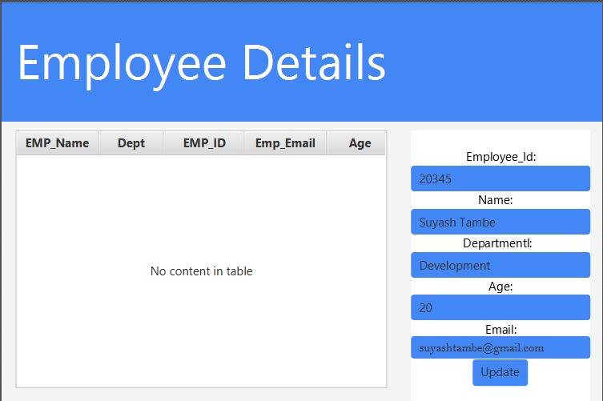

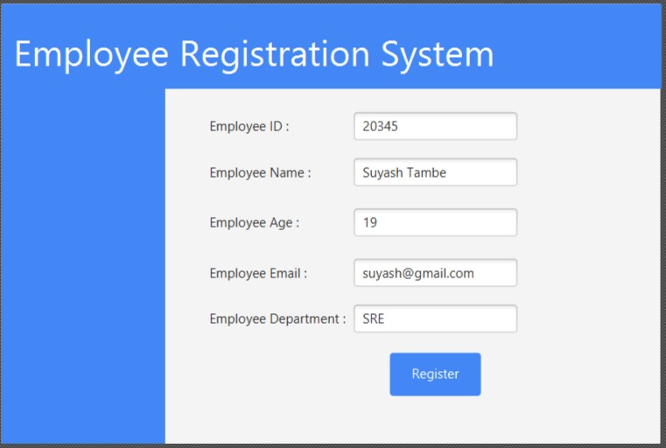

Github link : <https://github.com/suyashtambe>